**UI Design and Prototyping Report Template**

**Ristorante Con Fusion**

**1. Introduction**

* My Project is on a restaurant “Ristorante con Fusion”
* In home page there are some offers that are running in our restaurant at that time
* One can reserve their table in advance
* In the footer section there is the address and some social media links.
* About section basically highlights the history and speaks about our staffs in a nutshell.
* Contact us page basically contains our address and the location of the restaurant with a google map attached to it.
* In the last section of contact us page there is a form attached to it through which anybody can send any query to us.

**2. User Interface Design and Prototype**

* [Wireframe.cc – the go-to free, online wireframing tool.](https://wireframe.cc/TvjGNa)
* 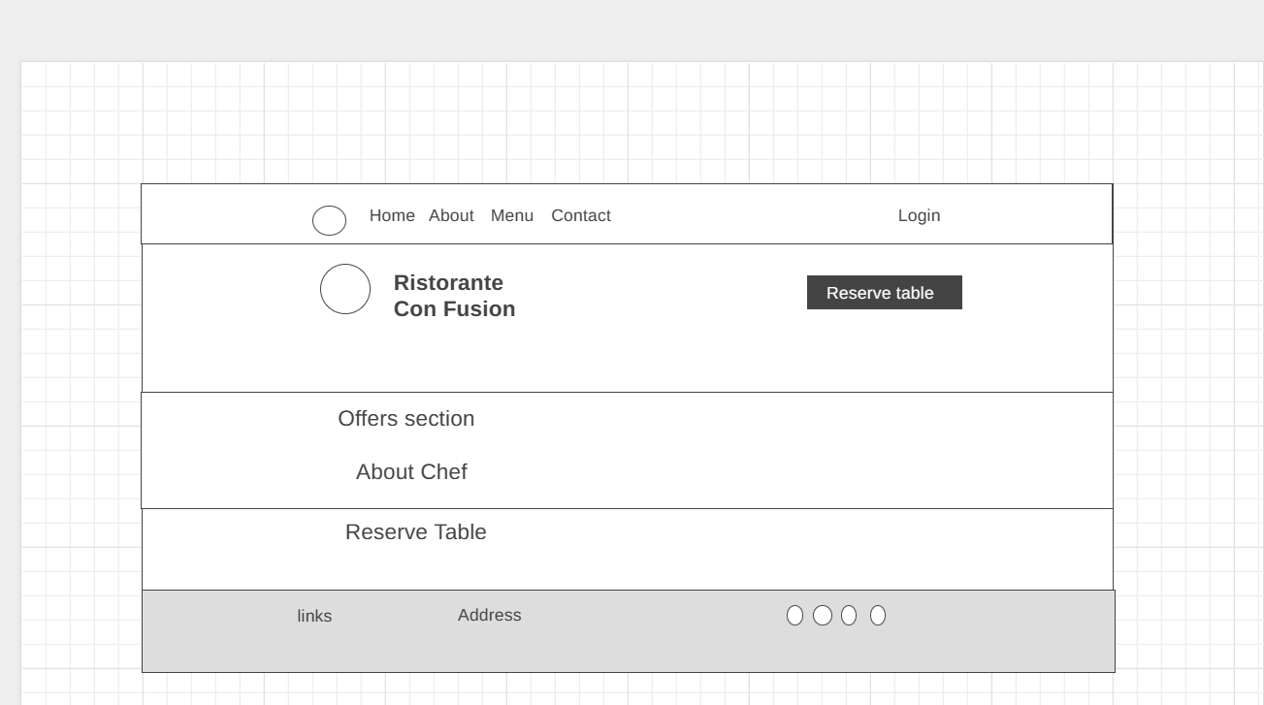

**3. Navigation Structure**

* In navigation bar we have Home About, Menu and Contact by clicking on the options we can navigate to the respective pages.
* First the user will log in to our website and come to the home page, form there he can reserve a table for himself,
* He can go to about section to get an idea about our restaurant.
* He can contact us from our contact page he can the log out.

**4. References**

* <https://youtu.be/qpH7-KFWZRI>.
* <https://www.freecodecamp.org/news/what-is-a-wireframe-ux-design-tutorial-website/>
* <https://www.experienceux.co.uk/faqs/what-is-a-website-prototype/>
* <https://www.freecodecamp.org/news/designing-a-website-ui-with-prototyping/>